How War laid the foundations for later developments and innovations in Computing

an expansion upon our debate:

“war has made the greatest contribution to computing”

Eoin Dowling: 16327673, Team A6 “Bits Please” | Computers and Society | 14/10/2016

# A Brief Summary of my Contributions to the Presentation:

For the team presentation, I was tasked to be on the Q&A panel. I was specifically requested to do so by my Team Leader and the rest of my teammates, as they told me that I was “very quick-witted”. While I think I my answers on the day of presentation a little long winded, I am proud of how I performed for such a challenging task.  
  
Moreover, I chose to help re-organize our presentation following our practice trial. I felt that while we had a very strong overall answer to our thesis statement, I felt that we didn’t articulate our answer with strong arguments during the current iteration of the slideshow. My aim was the centre our presentation more around three key arguments:

1. The greatest Innovations in computing were Invented for War Purposes
2. The Relationship between the timeline of War and of great
3. Later Development in Computing are indirect consequences of War.

Additionally, I changed the graphic design of our presentation, attempting to reduce the about of reading on the slides and adding careful aides such as images and animations.

# Personal Report

When we first received our thesis statement “XX has made the greatest contribution to computing” we were unsure as to ‘who’ XX would be. I suggested Alan Turing, another student argued that Steve Jobs and Bill Gates had made greater contributions to computing than Turing, while another suggested IBM. Eventually, it became clear to us that greatest contributor to computing was neither a person or a corporation, but it was the circumstance that gave rise to their innovations; War.

In the example of Turing and IBM, it is trivial to elaborate on this argument given that there is clear history to back it up. While Turing had done a lot of independent research on computing prior to the outbreak of the war at Cambridge, it took until the outbreak of World War II for his ideas to be brought to life; it was at Bletchley Park, under the war effort to crack the *Enigma* did he achieve building the Bombe. As for IBM, we need only look at the growth of the company during WWII to get a sense as to how much the War influenced the early IBM.

However, computing has come a long way since WWII, and the Cold War officially ended in 1991 when the Soviet Union Collapsed. So how can we attribute the innovations that, for example, Apple and Microsoft made to personal computing?  
Taking the example of the iPod released by Apple in the mid 2000’s, it is definitely not something people would associate with War. It was a breakthrough consumer device, that allowed people to listen to their personal music collection. However, what IS an iPod exactly? It is a small microprocessor powered computer with an LCD display, powered by Li-Ion batteries with a Hard Drive Disk large enough to store a large capacity of music. Now I ask the question; Where did the LCD display originate? Who invented the first microprocessor, and for what purpose?

Drawing on this particular slide from our presentation: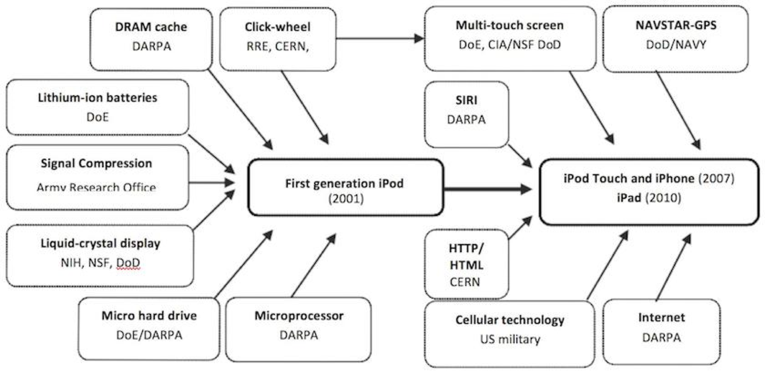

Here, we can argue that while the iPod itself wasn’t invented for War Purposes, it drew upon earlier innovations that were. Similarly, Microsoft gave us the modern Operating System designed with Multiple Users or Networking in mind, but a personal computing environment with a GUI, a mouse pointer and executable programmes running on onscreen windows. Again I ask where did these now underling software features originate?  
Turns out they have origins in research projects at various institutions of which received generous funding from DARPA, NASA and the DoD during the height of the Cold War.

When Steve Jobs was asked was to where he got his genius from, he once replied with a quote often attributed to Isaac Newton: *“If I have seen farther it is by standing upon the shoulders of giants”.*

I always thought that those giants were the likes of Ken Thompson and Dennis Ritchie, but as I progressed through my research for this assignment I became more and more aware of the giants working in the US defence sector who planted the seeds from which the computer industry flourished.

# Abbreviations:

NASA: National Aeronautics and Space Administration

WWII: The Second World War 1939-1945 (a.k.a World War II)

DARPA: Defence Advanced Research Projects Agency

DoD: the United States Department of Defence

Enigma: A German cryptography device used in the Second World War

Li-Ion: Lithium Ion, a type of battery

The Bombe: One of the first electromechanical computers